GAGN2HS05BU_H18_Skilaverkefni 3

Due date: 22-11-2018

- Create database called your_kenetala_company, use company.SQL file locate in inna.
Suppose we want to keep track of the total salaries of employees working for each department

- Create new table call deptsal as shown in the bellow.

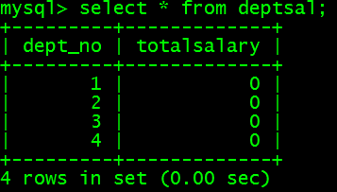

- Follow the steps to update the total salaries of employees for each department.
Step 1:
Change the delimiter (i.e., terminating character) of SQL statement from semicolon (;) to something else (e.g., //)
So that you can distinguish between the semicolon of the SQL statements in the procedure and the terminating character of the procedure definition

Step 2:
- Define a procedure called updateSalary which takes as input a department number.
- The body of the procedure is an SQL command to update the totalsalary column of the deptsal table.
- Terminate the procedure definition using the delimiter you had defined in step 1 (//)

Step 3: Change the delimiter back to semicolon (;)

Step 4: Call the procedure to update the totalsalary for each department

Step 5: Show the updated total salary in the deptsal table

- Write an SQL statement to display the list of stored procedures
- Write an SQL to remove the stored procedure
- Write an SQL statement that resets the totasalary to zero?
- Suppose we want to update all the rows in deptsal simultaneously, using while loop write, create an SQL procedure that updates all the rows?
- Create a stored procedure that updates all the rows simultaneously, using cursors?
- Create a procedure that will raise the salary of all employees by 10% ?.

Abdel

